**[Electricity](http://gcsephysics.com/pe.htm) Assignment 2 Test**

1.

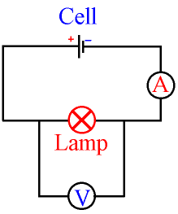

Calculate the power of the light in the circuit above if the ammeter reads 2 A, and the voltmeter reads 6 V.

P = V x I

= 6 x 2

   = 12 Watts.

2.

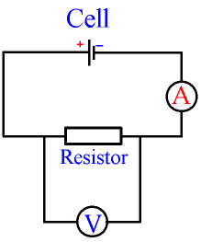

Calculate the resistance of the resistor in the above circuit if the ammeter reads 2 A, and the voltmeter reads 6 V,

V = I x R

R = V ÷I  
   = 6 ÷ 2  
   = 3 Ohms.

3.

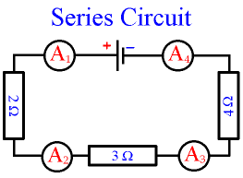

What will be the current readings on

A1

A2

A3

A1 = A2 = A3 = A4.

4.

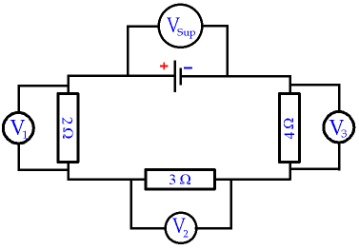

What is the relationship between V1, V2 V3 and Vsup ?

The voltage for all components adds up to the supply voltage (from the cell or battery). Vsup = V1 + V2 + V3. The supply voltage is divided (shared) between the components.

**5.**

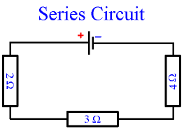

Calculate the total resistance in the above circuit,

Rtotal = 2 + 3 + 4

        = 9 Ohms.

6. Calculate the V1, V2, V3 and Vsup readings shown in the circuit below.

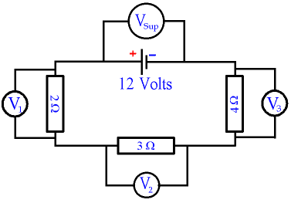

We can use V = I x R to find the current, which in a series circuit is the same everywhere.

I = V ÷ R  
   = 12 ÷ 9  
   = 1·333 Amps

Using the same equation V = I x R for each resistor in turn  
(and rounding up numbers) gives

V1 = 1·333 x 2  
    = 2·667 Volts.

V2 = 1·333 x 3  
    = 4·000 Volts

V3 = 1·333 x 4  
     = 5·333 Volts

V1 + V2 + V3 = 2·667 + 4·000 + 5·333  
  = 12 Volts.

7. Calculate all the ammeter readings shown in the circuit below knowing the supply voltage is 12V.

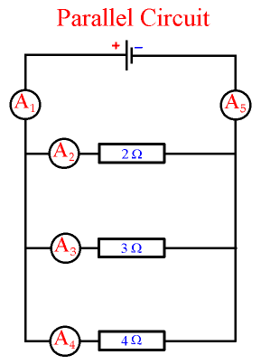

The current at A2 flowing through the 2 Ohm resistor  
can be found using V = I x R. If the supply voltage is 12 Volts,

I = V ÷ R

   = 12 ÷ 2

   = 6 Amps.

You would get the same answer for the 2 Ohm resistor,  
whether or not the other resistors are connected in the circuit. For parallel circuits, each component behaves as if it is connected independently to the cell, and is unaware of the other components

The current A3 flowing through the 3 Ohm resistor is

I = V ÷ R

   = 12 ÷ 3

   = 4 Amps

The current A4 flowing through the 4 Ohm resistor is

I = V ÷ R

   = 12 ÷ 4

   = 3 Amps

Notice that the bigger the resistance, the smaller the current.

The total current A1 or A5 is found by adding up the current in each branch.

A1 = A2 + A3 + A4

= 6 + 4 + 3

= 13 Amps

8.

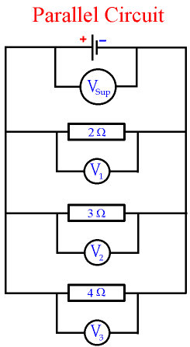

What is the relationship between all the voltmeters in the circuit above.

V1 = V2 = V3= Vsup.

9.

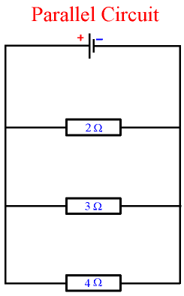

What is the total resistance of the above circuit,

1/R = 1/2 + 1/3 + 1/4

     = 6/12 + 4/12 + 3/12

= 13/12

R = 12/13

   = 0·92 Ohms

10.

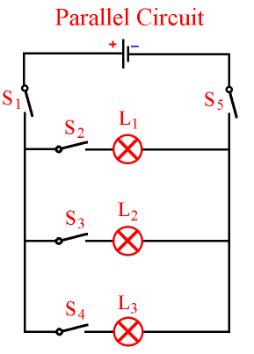

1. Wh
2. Which switches need to be closed for all lights to be on?
3. Which switches need to be closed for light L2 to be on?
4. Define the flowing in terms of **Mains Electricity – Safety**

* Insulation
* Fuses
* Earthing
* DoubleInsulation

**Insulation** means putting something which does not conduct electricity (an insulator) between a live conductor and yourself. Any metal is a conductor of electricity. Any non-metal is an insulator, with the exception of graphite which conducts electricity because of its unusual molecular structure.

The wires which we use to conduct electricity are made of a high purity copper metal, which is an excellent conductor. The insulator which covers the wires is a polymer called PVC (often just called "plastic"). It is an excellent insulator, flexible enough to bend around corners and cheap to make.

Insulation can become unsafe if it is damaged or wet because impure water will conduct electricity. Some appliances are double insulated.

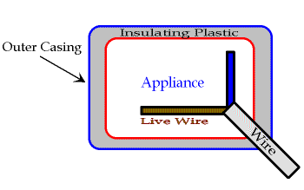Appliances with **Double Insulation** only need Live and Neutral wires; they do not need an Earth wire. An appliance which is double insulated has the whole of the inside contained in plastic  
underneath an outer casing. If anything goes wrong with the appliance, no live conductor can touch the outer casing because of the insulating plastic. Appliances which are double insulated include electric drills and hairdryers.

If the outer casing (the outside bit) of an appliance is a conductor (made of metal), then it can be made safe by E**arthing.** The Earth wire usually carries no electricity, it is connected to the metal case on the inside of the appliance.

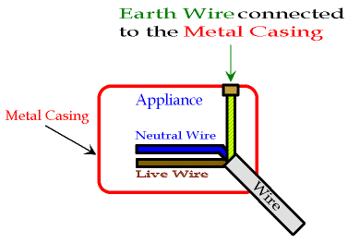

If something goes wrong inside the appliance and the Live wire touches the metal case, then the Earth wire acts like a Neutral wire  
and completes the circuit for the electricity. A very large current suddenly flows because the metal case has little resistance. This large current blows the fuse in the plug and disconnects the appliance from the power supply.

A **fuse** is a safety device which switches off an appliance if too large a current flows through the Live wire. The fuse is connected between the Live pin and the Live wire of a plug. The fuse has a rating printed on the outside in amps. If the current going through the fuse rises above its rated value, then the fuse "blows" (it melts) which turns off the appliance.

For example, if the fuse says 5 amps, then a current greater than 5 amps will blow the fuse. Fuses are given different colours for different ratings. This is called colour coding. A 2 amp fuse is blue,  
3 amp is red, 5 amp is black (or very dark blue),  
13 amp is brown.

1. Define 1kWh (one kilowatt-hour), kilo means thousand, so one kilowatt-hour is the amount of electricity used by a 1000W appliance running for 1 hour. 1 Watt is 1 Joule per second, 1000W = 1000J per s. 1 hour = 60 x 60 seconds, = 3600 seconds. Therefore, 1kWh = 1000 x 3600 Joules, = 3,600,000 Joules of energy. Note that a kWh is a unit of energy, not power.